# Project Design Phase-I

# Solution Architecture

|  |  |
| --- | --- |
| **Date** | **05 November 2022** |
| **Project Name** | **Project – News Tracker Application** |
| **Maximum Marks** | **2 Marks** |

**Solution Architecture:**

Solution architecture is an complex process ,with many sub-processes that the gap between business problems and technology solutions. Its goals are to:

* Find the best tech solution to solve existing business problems.
* Describe the structure, characteristics, behavior, and other aspects of the software to project stakeholders.
* Define features, development phases, and solution requirements to the project.
* Provide specifications according to which the solution is defined, managed, and delivered to the customers.

# Example - Solution Architecture Diagram:

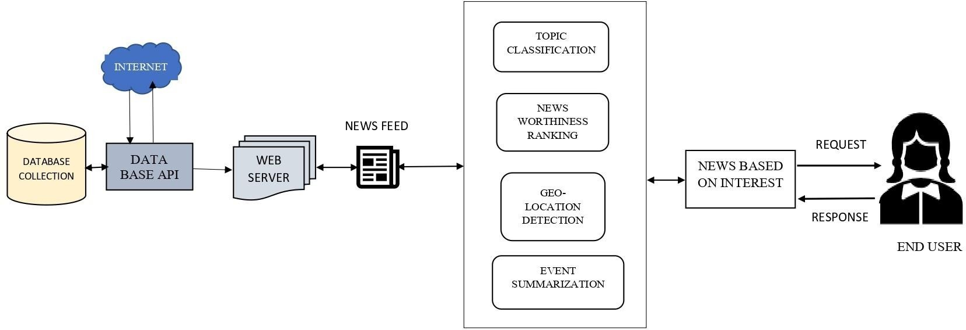

NEWS TRACKER APPLICATION